(Approx. 1304)

COMPLETE ROBOCALL DETERRENCE
A two-step approach: prevent the ring and convince the robocaller that your line is disconnected.
Part 2 of a three-part article series
By John Krout, Presenter & Newsletter Contributor
Potomac Area Technology and Computer Society
https://www.patacs.org
jkrout.apcug.presenter (at) gmail.com

INTRODUCTION

In Part 1 of this series, you learned how to configure your smartphone so that only your Contacts will ring your phone, a Whitelist strategy.

That Whitelist solution is not complete because robocaller systems can still find out that your phone is live simply by recognizing that the call went to your voicemail. And you continue to suffer the frequent voicemail inbox overload syndrome since many robocallers leave voicemails.

This part 2 article introduces the concept of including the Special Information Tones (SIT). The three tones beginning phone network messages, such as the number you dialed, are disconnected at the start of your voicemail greeting. After SIT, you can include your voice telling your Contacts that your number is indeed live, not disconnected, and they can leave a message.

WHY SIT?

Robocaller systems, like any valuable asset, are focused on the efficient use of system time. So each robocaller system maintains an internal list of phone numbers known to be valid.

How can robocaller systems determine that a called number is not valid? When the phone number is disconnected, i.e., the system hears SIT. When robocaller systems hear SIT, the systems remove the number from their internal list of numbers known to be valid. Then, they don’t call again.

The proof is in the pudding, as some say. In September 2019, I was receiving about 25 robocalls per week and roughly ten robocall voicemails per week. I implemented this SIT voicemail greeting strategy in July 2020. Between that time and March 2021, when I wrote this article, I typically received only two robocalls per week in Missed Calls, and my weekly robocall voicemails dropped to zero.

Why do I still receive any robocalls? First, because there are hundreds or perhaps thousands of robocall systems, some systems have yet to call and hear SIT.

CARRIER OPTIONS FOR VOICEMAIL GREETINGS

Typically, phone carrier companies, such as Verizon Wireless, AT&T, and T Mobil, offer three different ways to create a voicemail greeting.

- Automatically state your phone number, for instance: You have reached 703-555-1111. Please leave a message after the beep.

- Play a recording of you pronouncing your name, for instance: You have reached the phone of John Krout. Please leave a message after the beep.

- Play a recording of whatever you want to say for your greeting.

So, our strategy will be to use the third option, a recording, to make robocaller systems think your phone line is disconnected. Most phones expect you to use the phone’s microphone and your own voice to record that voicemail greeting.

Below, I will show you how to combine SIT and your greeting on your computer. Then, in Part 3 of this article series, I will show you three ways to transfer that combined audio into your phone for use as a voicemail greeting.

HOW TO GET SIT

There are websites that curate phone network messages. I downloaded a couple of those messages and used the free Audacity sound editor to isolate SIT and remove audio noise.

I have posted that cleaned-up SIT online as a monophonic WAV file on the Web. You can download it from:

https://tinyurl.com/6n5hyb6d

MAKE YOUR GREETING SCRIPT

Before recording, I suggest you type your voicemail greeting script in a document in a large font, so you can read it easily while recording.

Here’s what I used as a script:

Hi, this is John. No, my number is not disconnected. Those tones were just meant to convince robocallers not to call me again. You can leave a message after the beep. Thanks.

RECORDING YOUR VOICE

No matter how you record, the phone carriers require that your custom voicemail greeting has to be monophonic, not stereo. You can either record monophonic or use Audacity to reduce the recording from stereo to monophonic.

One convenient way to record your voice is to use a voice recording app on your phone and then transfer that digital greeting audio file to the computer. Android users can download any of several voice recording apps from the Google Play Store. Ensure the app documents the phone folder in which you can find the digital audio recording file for transfer to your computer. For example, iPhone users can find the Voice Memos app in the Accessories folder. Recordings can be transferred to the computer using iTunes sync.

Alternatively, if you obtained a computer microphone for virtual online meetings during the pandemic, or your laptop has a built-in microphone, you can record your voice directly to your computer using an application such as the frees Audacity audio editor.
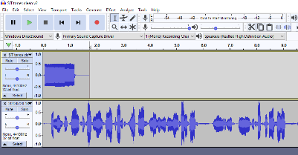Illustration 2
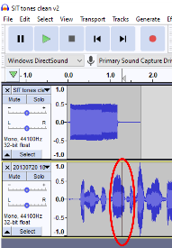Illustration 3
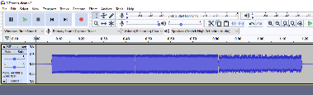Illustration 1
COMBINE SIT AND YOUR VOICE RECORDING

Audacity provides a convenient multi-track method for doing this task.

STEP 1. Open Audacity, pull down the File menu and select Open. Then, using the standard Open File dialog box, load the SIT recording. After you do that, the oscilloscope-like depiction of the SIT recording appears in an Audacity track, like that shown in Illustration 1.

STEP 2. In Audacity, pull down the File menu and select Import. Then, using the standard Open file dialog box, load the voicemail greeting recording.

Audacity places that imported voicemail greeting recording in a second track, below the track that contains the SIT recording. You can see an example in Illustration 2. Audacity adjusts the time scale so that the longer track is completely visible.

However, both audio recordings start at the same time. Therefore, we need to move the voicemail greeting recording to the right to start after SIT ends. Here is how to that happen.

STEP 3. In the second track, click at the time point where SIT ends. A black vertical cursor will appear in the second track. Again, you can see an example in Illustration 3. In that illustration, the vertical cursor is circled.
STEP 4. Pull down the Tracks menu. In that menu, select Align Tracks.
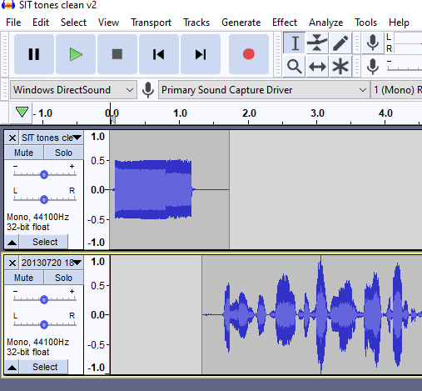Illustration 5
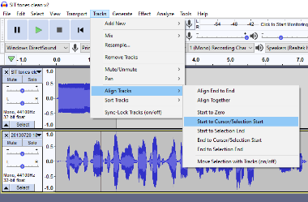Illustration 4

A sub-menu appears. In that sub-menu select Start to Cursor/Selection Start. This choice means that the track in which the cursor appears will be moved to the right so that the audio starts at the cursor.

You can see the menus and choices in Illustration 4.

Audacity moves the voicemail greetings in the second track to the right, to the point where you set the cursor. You can see an example in Illustration 5.

At this point, your custom ringtone is ready to be auditioned. The play controls in Audacity look like CD player or MP3 player controls, including a Start at Beginning button, a left-pointing black triangle with a vertical black bar, and a green triangular Play button. Those buttons appear in Illustration 5, just below the Audacity main menu bar where File and Tracks appear.

Click Start at Beginning and then Play. If you like the result, I strongly suggest you pull down the File menu and Export the result to a WAV file as a backup.

If you do not already have Audacity installed on your computer, here is the download link:

https://www.audacityteam.org/download/

NEXT UP

In part 3 of this article series, you will learn how to transfer that combined greeting audio to your phone for recording as a voicemail greeting.

ABOUT THE AUTHOR: John Krout has been writing about creative uses of personal computers since the early 1980s, and more recently, about creative uses of smartphones. He finished a long career as a software engineer with 14 years as a technical writer for a federal contractor. He lives in Arlington, Virginia, with his son, many computers and cameras, and too many cats.

